Guess the Color
Lauren Powell and Josh Chery
COP 1500 - CRN 80597
Group 9

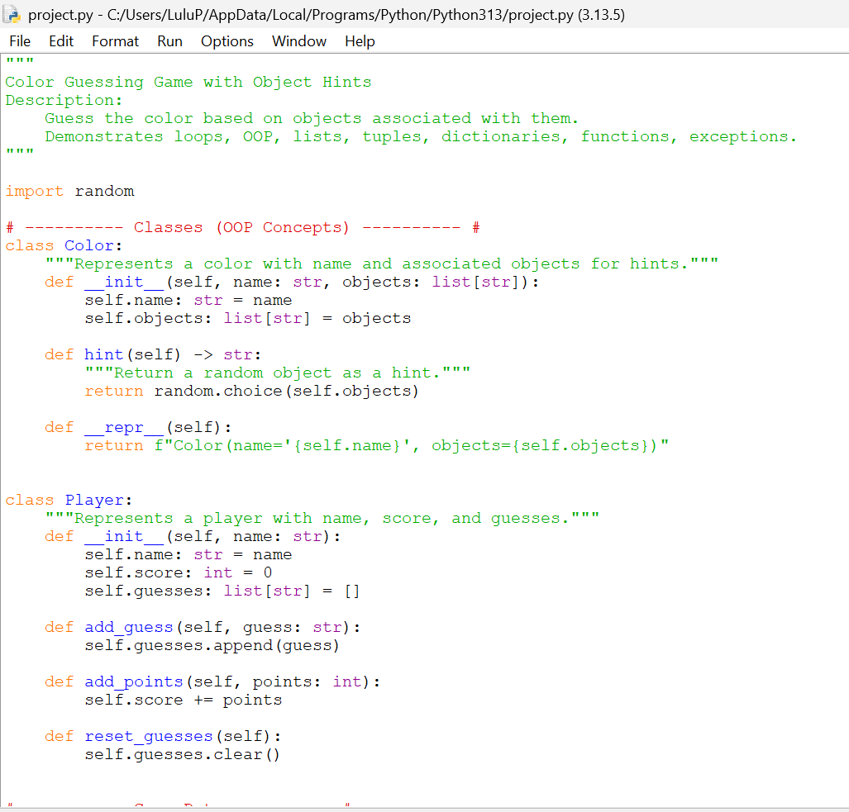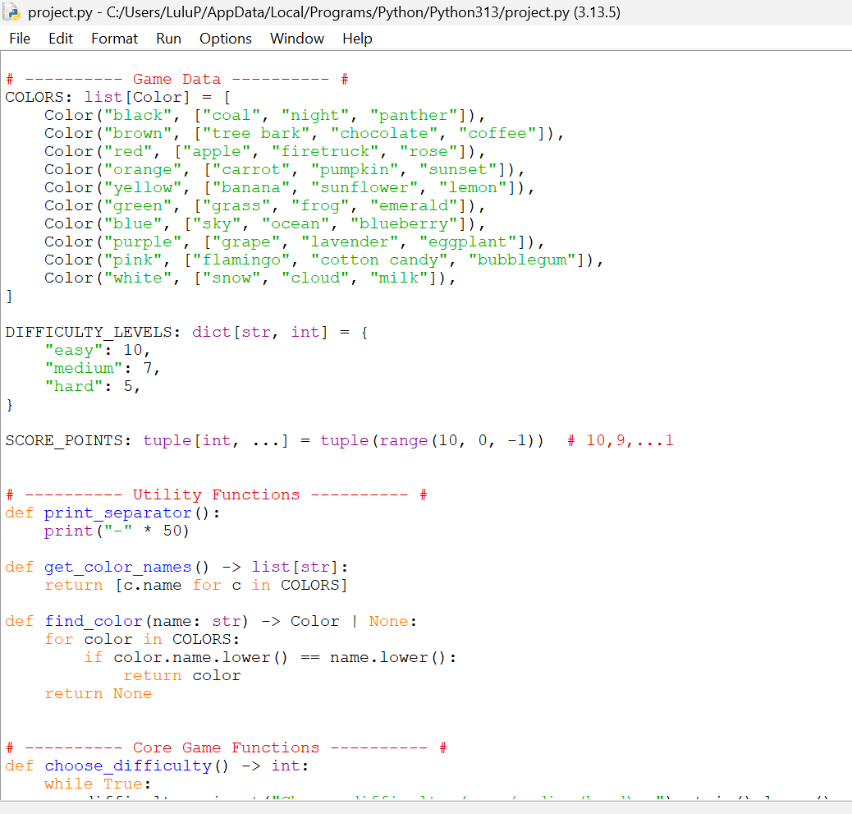
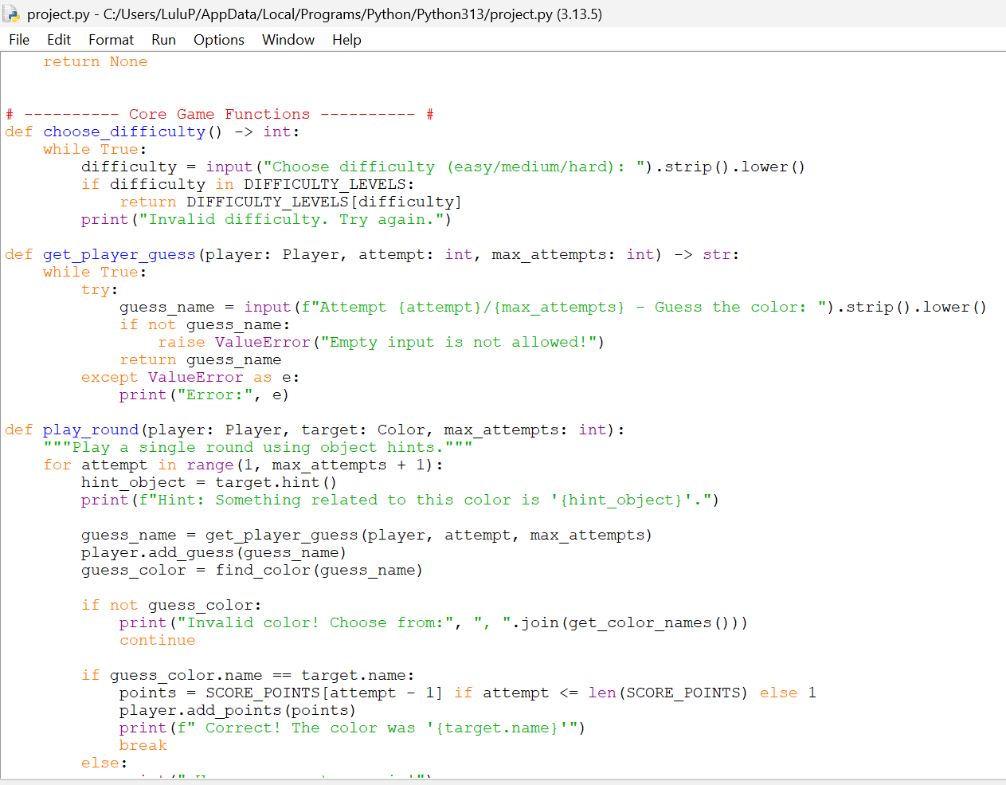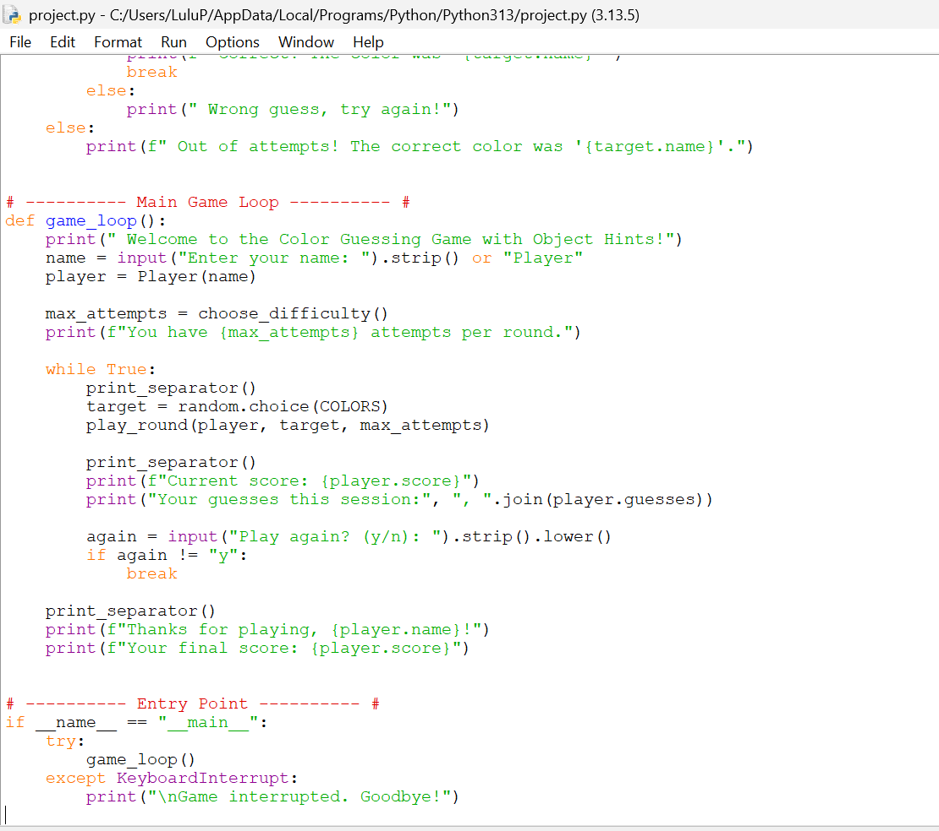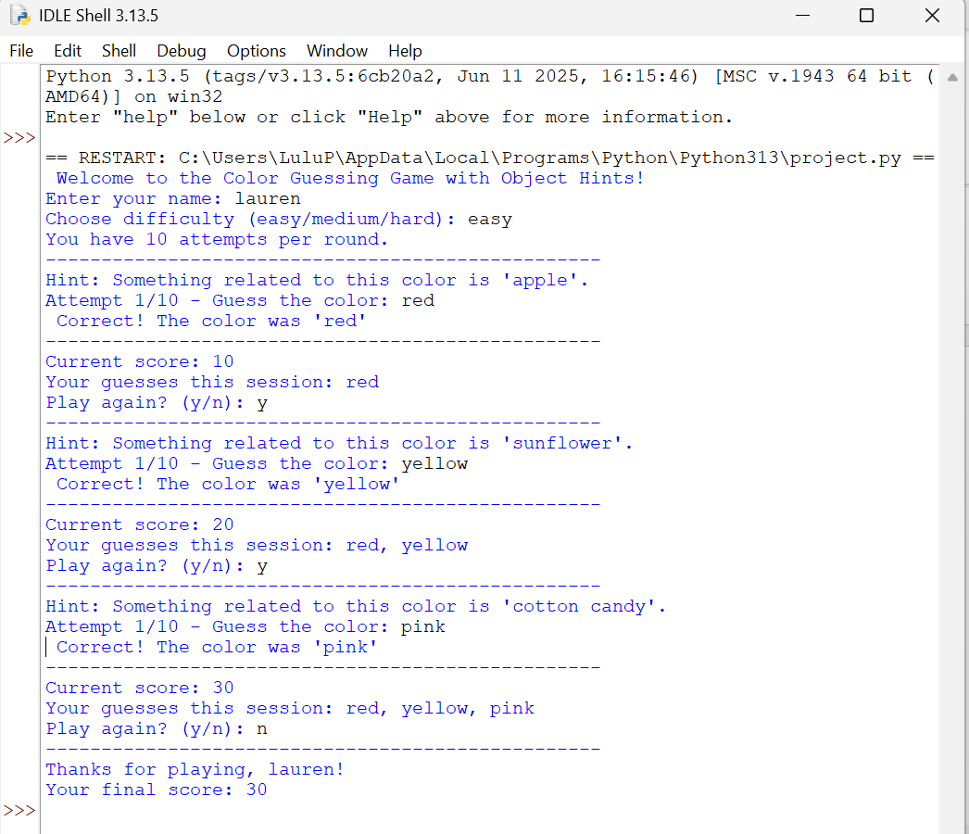
Abstract
This project presents a Python-based Color Guessing Game that uses object-oriented programming, data structures, loops, functions, and exception handling to create an interactive user experience. Each color in the game is represented as an object containing a name and a list of associated real-world items that serve as hints. A player object tracks the user’s name, score, and guess history. The game allows the user to select a difficulty level, which determines the number of allowed attempts. During each round, the program randomly selects a color and provides object-based hints until the player correctly identifies the color or runs out of attempts. Overall, this program shows how multiple Python features can work together to build a functional and engaging game
Goal of the Project:
The goal of this project is to make a color guessing game that uses different Python features and shows I understand how to use classes, loops, functions, and error handling in a real program
Software requirements:
-Pycharm
-Idle
-Python 3.13
-laptop
Introduction
Why you chose this topic?
Existing technique and your improvisations to the existing concept.
Project Concept and procedure in detailed steps (flow diagrams, steps)
Result Discussion
Screen shots to be provided for various inputs or a short video file can be attached explaining the
output.
Conclusion: What do you conclude from the work you have done and Is there any technique that
you would consider to improvise your work?
Git Hub Link should be provided and source code should be made public till the work is
graded.

